Elitemeatsutah.com

Media Sources

https://www.flickr.com/photos/mypubliclands/24936183702

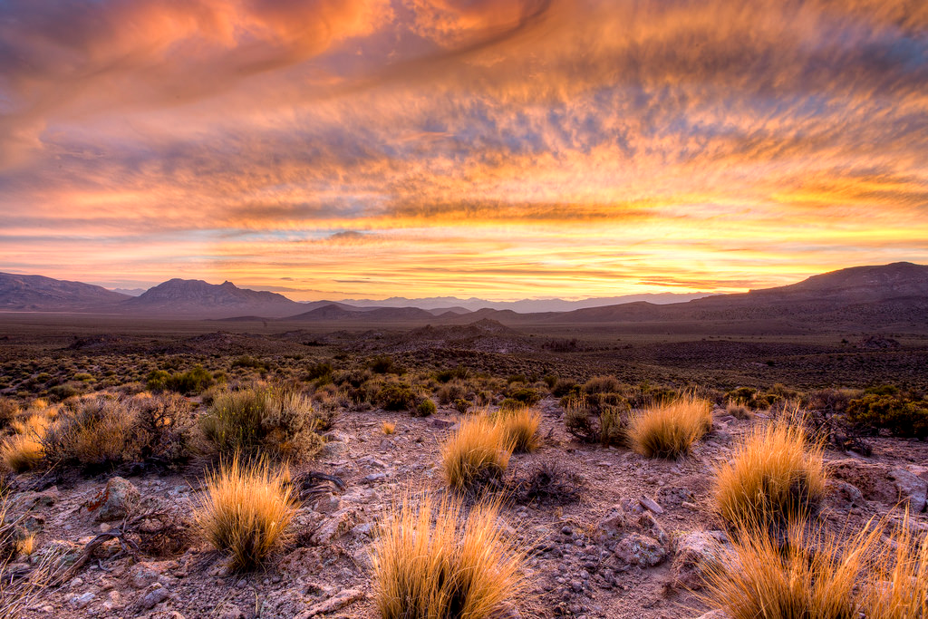

https://en.wikipedia.org/wiki/User:MCB

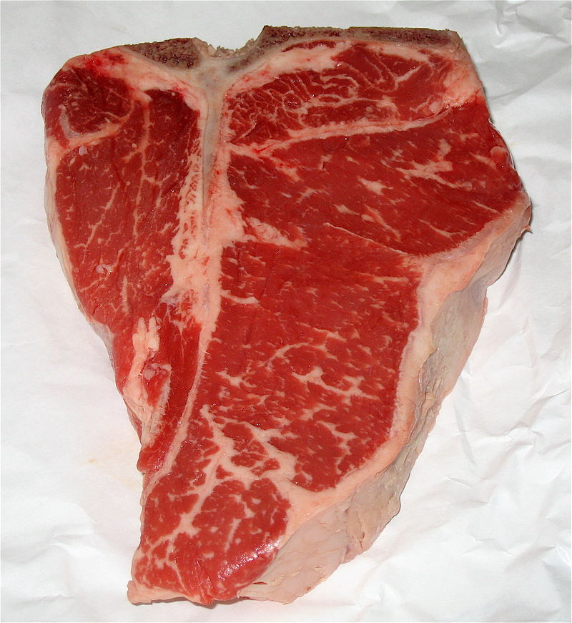

[https://en.wikipedia.org/wiki/File:Strip-steak-MCB-MaggieO.jpg](https://en.wikipedia.org/wiki/File:Strip-steak-MCB-MaggieO.jpg#)

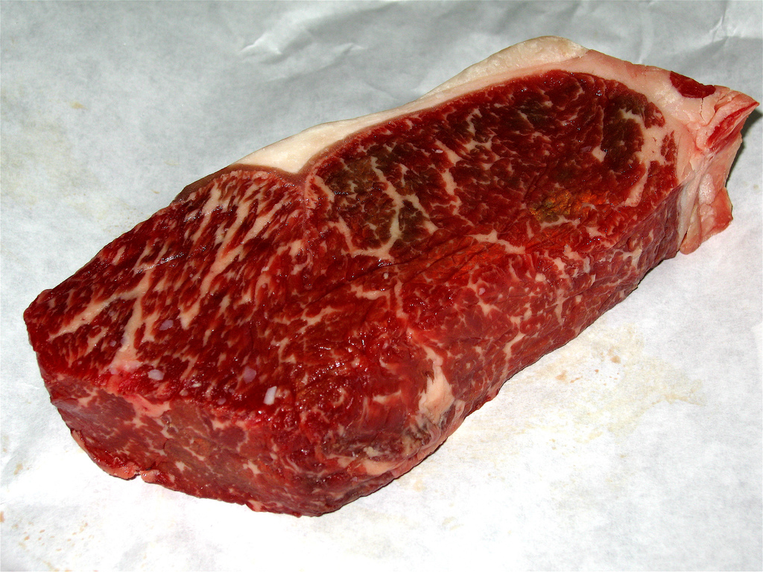

https://www.flickr.com/photos/alexik/3313248278/in/photostream/

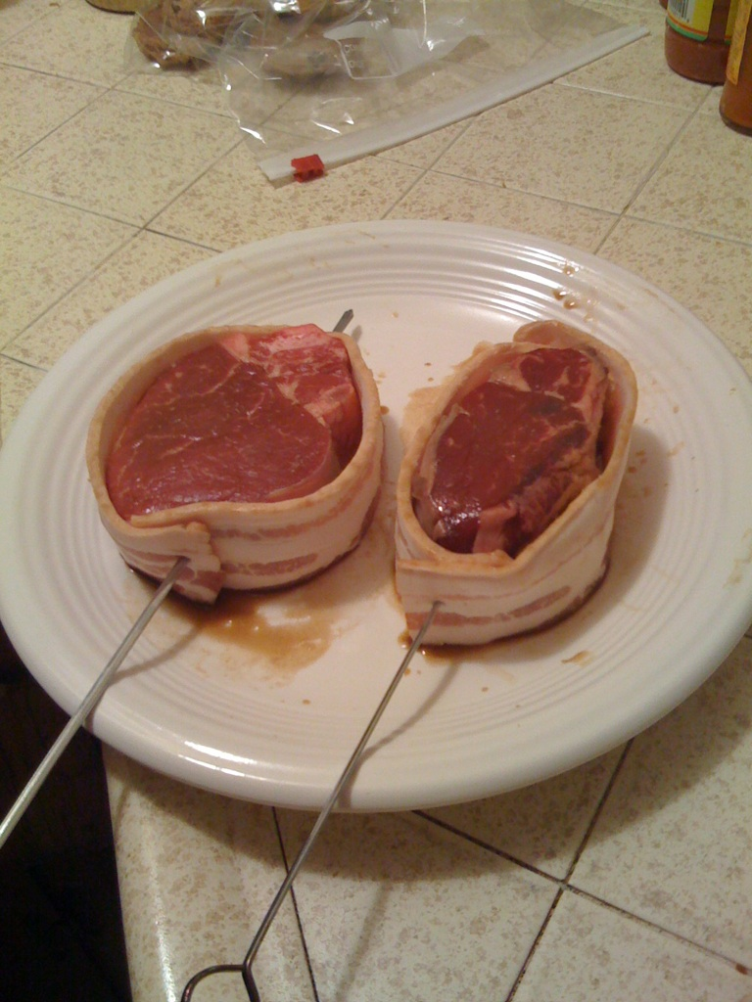

<https://en.wikipedia.org/wiki/Strip_steak#/media/File:StripSteak.jpg>

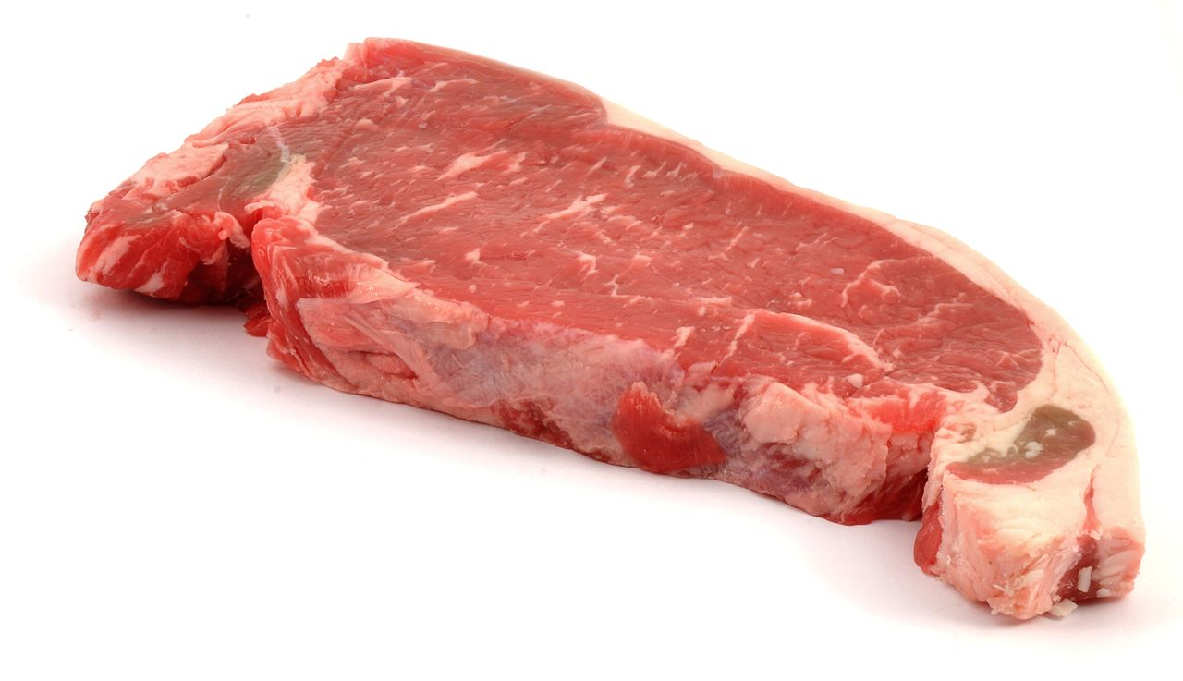

<https://www.flickr.com/photos/55935853@N00/6548177035/in/photolist-aYD7U4-A98C4H-ja1hqR-q3Uc4A-qks3Qr-6hyuLv-dTYYHc-buoKqm-66jT7G-4r91nm-asXSBk-a4T7tW-5UVYL6-afL4v1-4r4WUB-5UVYgB-7W6Xdt-ja4u9h-66fB5e-4CVFWN-bvHMD7-aEW56y-6Y1Q8H-5Q3Rqh-6hCE1b-4xvPuy-6GeDcg-4CRr6v-8ww3Kh-KccSs-o1ULDe-8w96ht-xnHb57-ytpB1w-wkpJqL-8f5S6x-6hCDMd-4NR5Jo-fo98gp-a4gCtH-4r4VUi-4mJPoW-nSDywv-6hyvpT-6U169i-6hyvap-4GBXVB-47GG-3qjzN8-5pKAQa/>

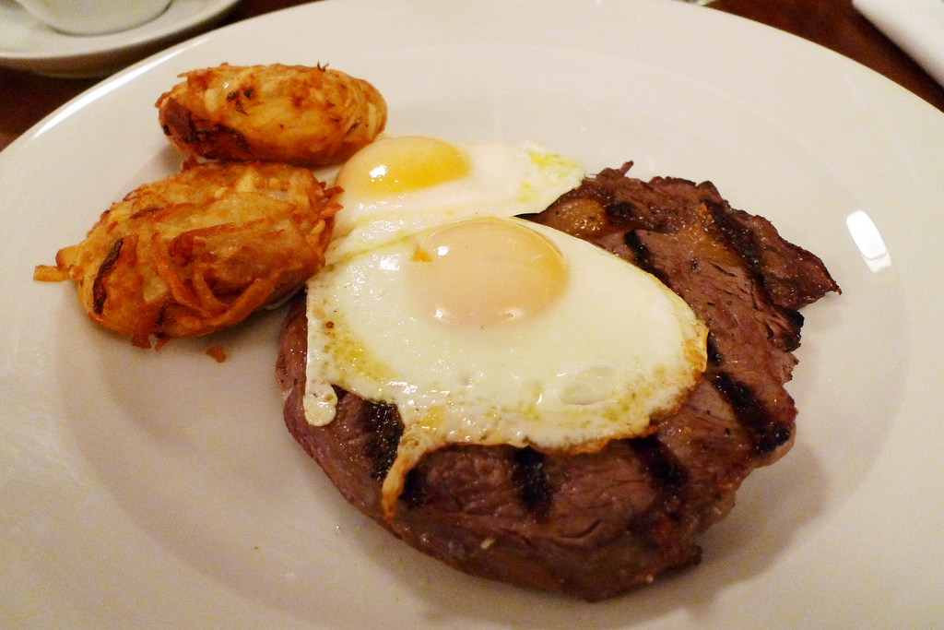

<https://www.flickr.com/photos/firsttubedotcom/2292137287>

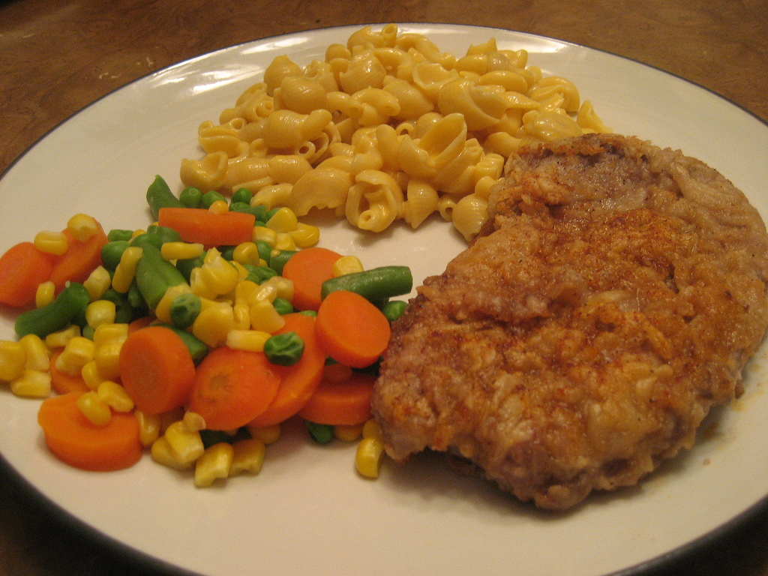

<https://www.flickr.com/photos/firsttubedotcom/2292137287>

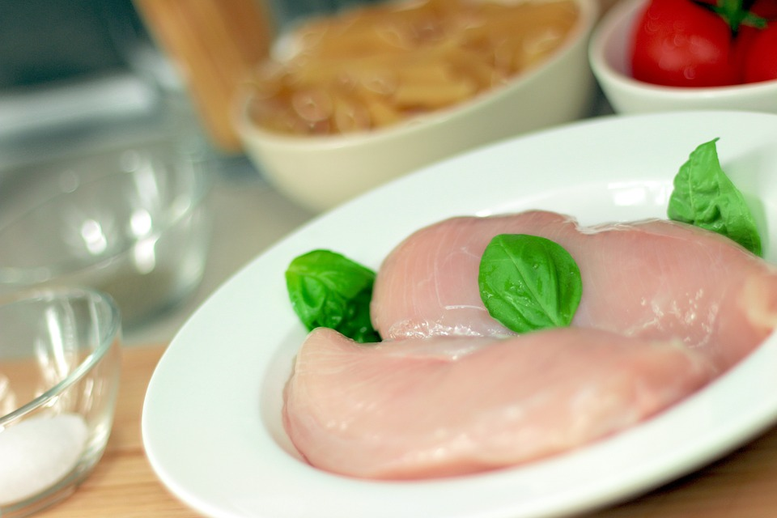

<https://www.flickr.com/photos/candyb/4508323051>

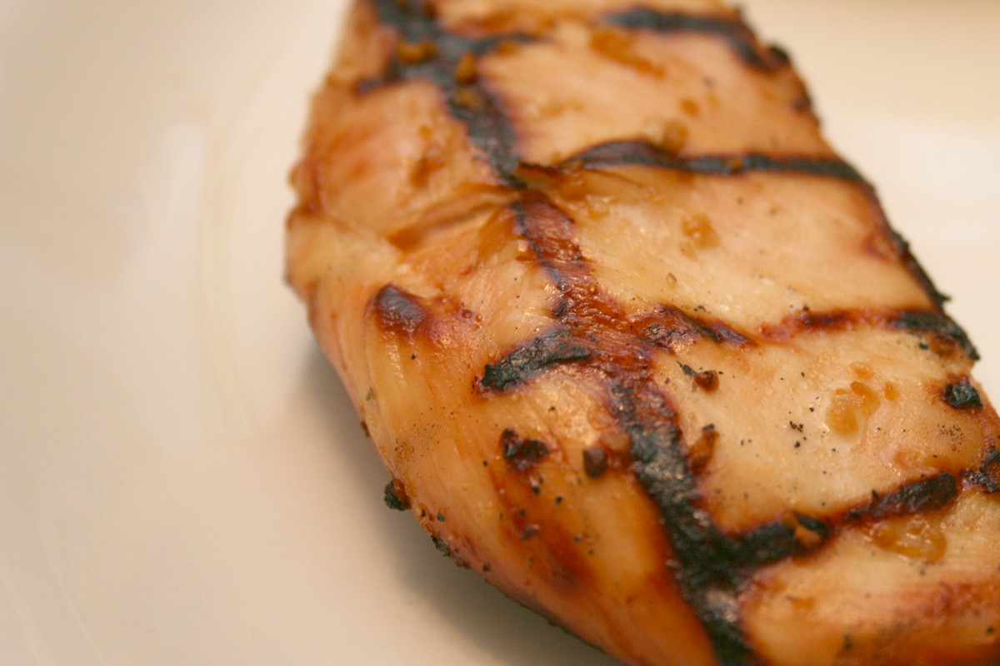

[http://creativecommons.org/publicdomain/zero/1.0/deed.en](http://creativecommons.org/publicdomain/zero/1.0/deed.en#)

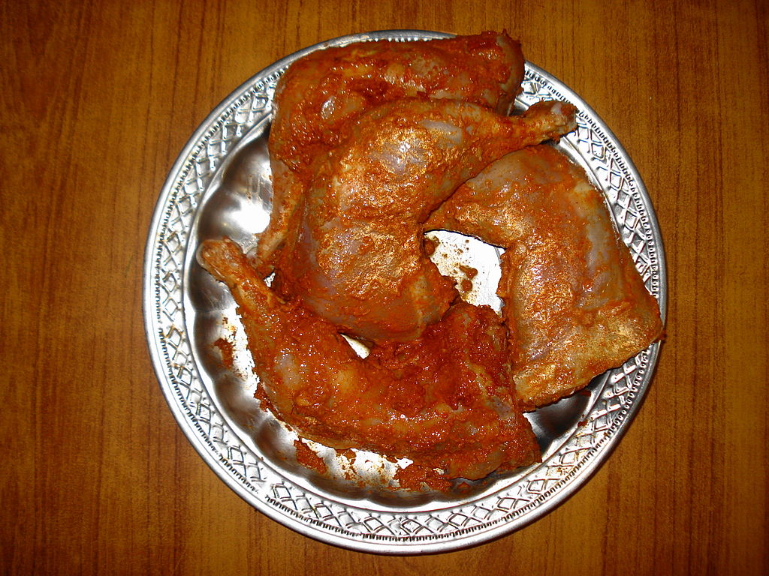

<https://en.wikipedia.org/wiki/Chicken_parmigiana#/media/File:Chicken_parmiagana.jpg>

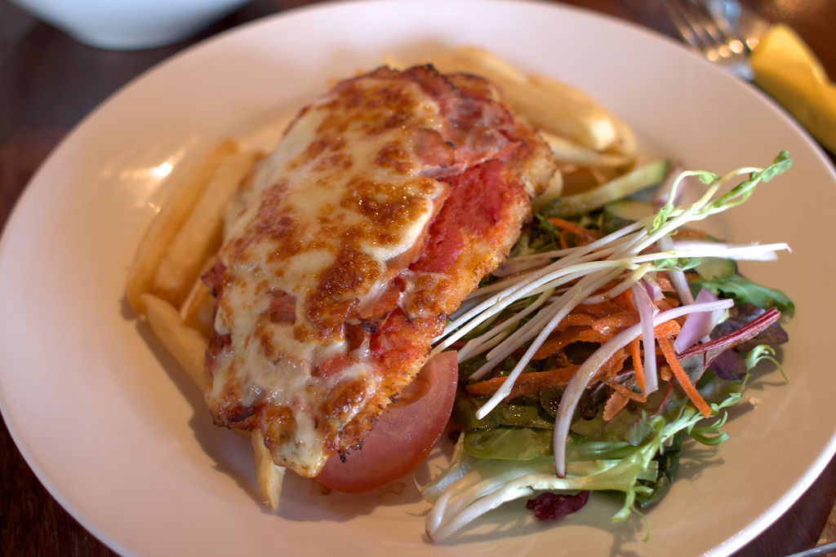

[https://en.wikipedia.org/wiki/Yakitori#/media/File:Yakitori_by_MShades_in_Kujo,_Kyoto.jpg](https://en.wikipedia.org/wiki/Yakitori#/media/File:Yakitori_by_MShades_in_Kujo,_Kyoto.jpg#)

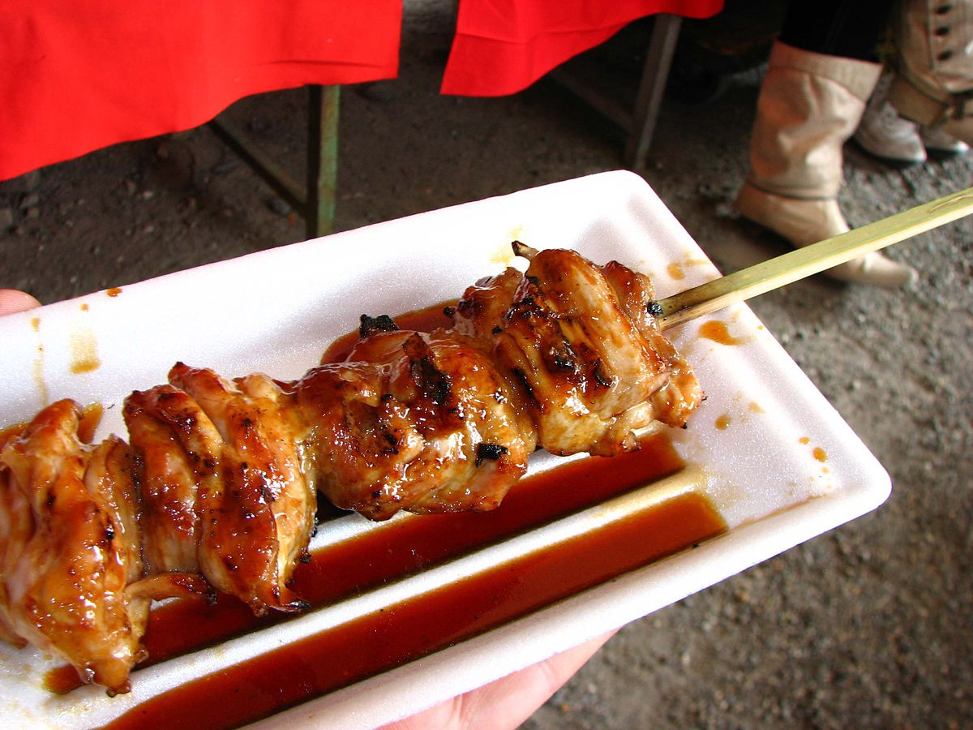

<https://en.wikipedia.org/wiki/Chicken_fingers#/media/File:Crispy_Chicken_Strips_-_FotoosVanRobin.jpg>

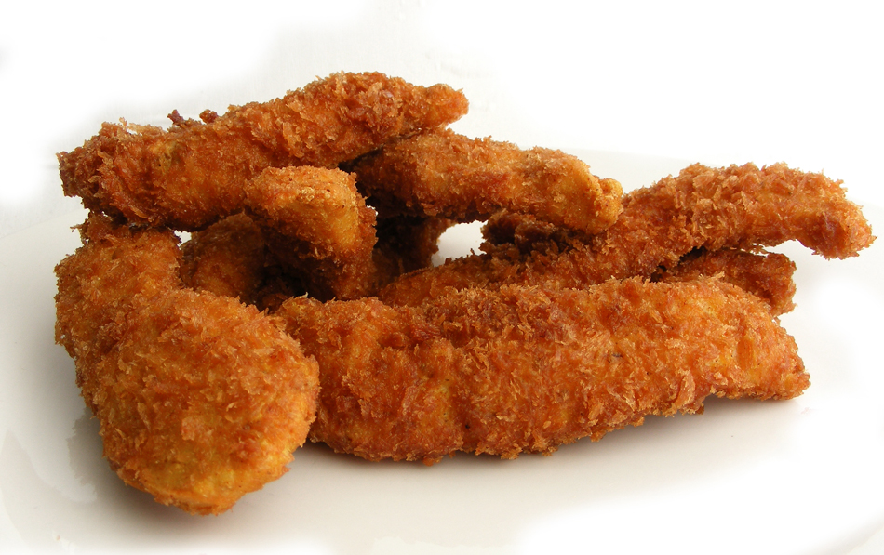

<http://www.freepik.com/free-photos-vectors/people>

